A REAL-TIME ECG MONITORING SYSTEM WITH CONTEXT-AWARE 1D CONVOLUTIONAL NEURAL NETWORK INTEGRATION

Abdiel Ivan Rivandi1*, Abba Suganda Girsang1, Petra Michael2, and Dani Suandi2
¹ Computer Science Department, BINUS Graduate Program – Master of Computer Science, Bina Nusantara University, Jakarta 11480, Indonesia.
² Computer Science Department, School of Computer Science, Bina Nusantara University, Jakarta 11480, Indonesia.
*abdiel.rivandi@binus.ac.id / https://orcid.org/0009-0006-6758-0777

Abstract. This study presents the design and development of a real-time ECG monitoring application that integrates a context-aware one-dimensional Convolutional Neural Network (1D-CNN) for automated arrhythmia detection. The embedded deep learning model was previously validated using a modified MIT-BIH Arrhythmia Dataset with strict record-wise splitting to ensure patient-independent evaluation. To enable practical deployment, the model is integrated into an application-level architecture featuring a rolling buffer mechanism that constructs seven-beat context windows from continuous ECG streams. The application provides real-time signal visualization, automated classification of normal and abnormal heartbeats, and probability-based decision support through an interactive user interface. Experimental results demonstrate that the integrated system achieves an accuracy of 98.03% on unseen test data, while maintaining 94% accuracy in a zero-shot real-time simulation using an unmodified patient record. These findings indicate that the proposed application successfully bridges the gap between deep learning-based ECG analysis and practical clinical usage, offering a robust foundation for real-time cardiac monitoring systems on edge or wearable devices.
Keywords: ECG, Arrhythmia Detection, 1D-CNN, Real-Time Application, Clinical Decision Support

Introduction

Cardiovascular diseases (CVDs) remain the leading global cause of mortality, with cardiac arrhythmia serving as a critical indicator of compromised heart health [1]. While some arrhythmias are benign, pathological variants can precipitate severe outcomes like stroke and sudden cardiac arrest [2]. Given the sporadic nature of these disorders, where normal rhythm is often interrupted only by fleeting episodes [3], the electrocardiogram (ECG) remains the gold standard for monitoring [4]. However, manual interpretation is labor-intensive and prone to inter-observer variability, especially in long-duration recordings where fatigue reduces diagnostic sensitivity [5], [6]. Furthermore, signal artifacts can obscure morphological features, necessitating automated Deep Learning (DL) systems capable of analyzing data with speed and consistency exceeding human capabilities [7], [8].
Automated detection has evolved from heuristic feature engineering to "end-to-end" DL frameworks. Early methods relied on hand-crafted features like Heart Rate Variability (HRV), which depended on precise R-peak detection and lacked robustness against noise [9], [10]. The shift to Convolutional Neural Networks (CNNs) enabled autonomous feature extraction from raw data [11]. Kiranyaz et al. (2016) proved 1D-CNNs superior for patient-specific classification [12], while Acharya et al. (2017) utilized deep architectures to capture QRS variations [13]. Hybrid models combining CNNs with Long Short-Term Memory (LSTM) have also been explored to model temporal dependencies [14], [15]. However, critical methodological flaws persist in the existing literature, compromising clinical utility [16].
Two pervasive gaps undermine current research: "data leakage" and the neglect of temporal context. Many studies employ "intra-patient" splitting, randomizing heartbeats from the same patient across training and testing sets [16], [17]. As summarized in Table 1, this splitting strategy, combined with single-beat classification [18], often yields high theoretical accuracy but fails to generalize to new patients [19], [20]. Furthermore, models analyzing isolated beats ignore the rhythmic relationship between consecutive beats, which is essential for diagnosing complex arrhythmia like Bigeminy. Consequently, none of the listed related works offer a fully integrated system capable of real-time deployment on unseen patients.

Table 1. Comparison of related works and the proposed method.
Methodology | Input Representation | Splitting Strategy | Accuracy | Integrated System | Ref.
HRV Analysis | Hand-crafted Features | N/A | 85% | No | [17]
1D-CNN | Patient-Specific ECG | Intra-patient | 98% | No | [26]
Deep 9-Layer CNN | Single Heartbeat | Intra-patient (random) | 94.03% | No | [10]
CNN + Spatial Pyramid Pooling | Heartbeat Segments | Inter-patient | 99% | No | [20]
CNN + LSTM Ensemble | Long Sequences | Inter-patient | 83% | No | [21]

To bridge these gaps and surpass the limitations highlighted in Table 1, this study proposes a context-aware 1D-CNN framework integrated into a real-time clinical support system. Unlike prior works, we utilize the MIT-BIH Arrhythmia Database [21] to engineer a 7-beat context window mechanism [22]. By processing a target beat flanked by three preceding and three subsequent beats, our model simultaneously captures local morphological features and global rhythmic patterns. We enforce a strict record-wise splitting strategy, ensuring that the model is evaluated exclusively on unseen patients to prevent data leakage [23], [24]. This rigorous approach achieves a high generalization accuracy of 98.03% on the test set. Crucially, we extend beyond theoretical modeling by deploying the trained network via an ONNX inference engine within a rolling buffer architecture, creating a fully integrated system validated for real-time latency and robustness [25].

The paper is organized as follows: Section 2 details the data modification, 7-beat window construction, and 1D-CNN architecture. Section 3 presents experimental results, including performance metrics and a zero-shot real-time simulation on an unmodified record. Section 4 concludes with future directions for edge deployment.

Methodology

Data Source and Modification
The study utilizes the MIT-BIH Arrhythmia Database [19], specifically selecting Lead II signals sampled at 360 Hz due to their distinct P-QRS-T morphology [5]. To facilitate robust binary screening, the original AAMI classes were consolidated into two categories: Normal (N) and Abnormal (A), where the latter aggregates all pathological events including PVC, APB, and LBBB.
Prior to model ingestion, raw signals undergo a rigorous transformation pipeline. First, the Pan-Tompkins algorithm [24] is employed for precise R-peak detection. Based on these peaks, an asymmetric window of 200 samples (approx. 556 ms) is extracted for each beat to capture the full cardiac cycle.
To overcome the limitations of single-beat analysis, we engineered a 7-beat context window. As illustrated in Fig. 1, this mechanism selects a target center beat flanked by three preceding and three subsequent beats. This wide receptive field preserves the "local rhythm," enabling the model to distinguish arrhythmias defined by inter-beat patterns (e.g., Bigeminy) rather than isolated morphology [20].

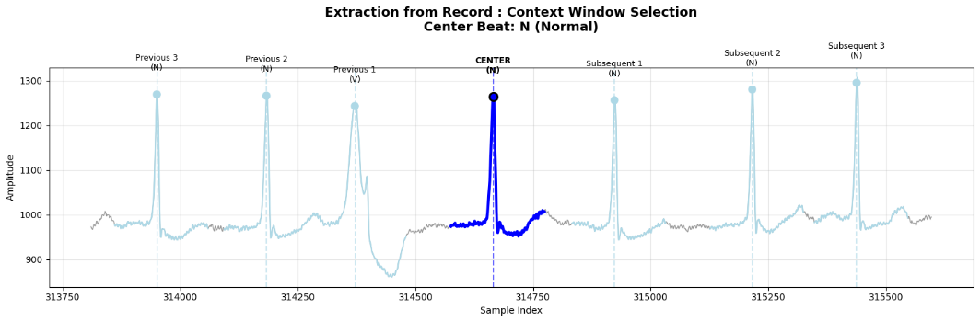

Fig.1 Extraction of the 7-beat sequence from the continuous ECG recording.

Subsequently, the selected sequence is decomposed into seven individual beat segments (Fig. 2) to retain fine-grained morphological details.
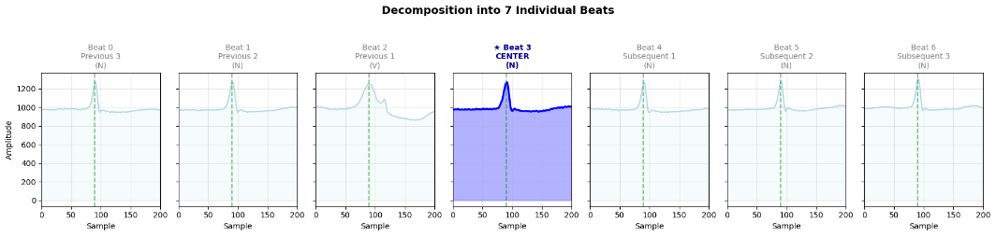Fig.2 Decomposition of the sequence into 7 individual beat segments.

Finally, these segments are stacked to form a spatial-temporal input tensor of dimension 7 x 200, as depicted in Fig. 3. This matrix serves as the direct input for the 1D-CNN, allowing the network to simultaneously learn spatial features (waveform shape) and temporal dependencies (beat intervals).

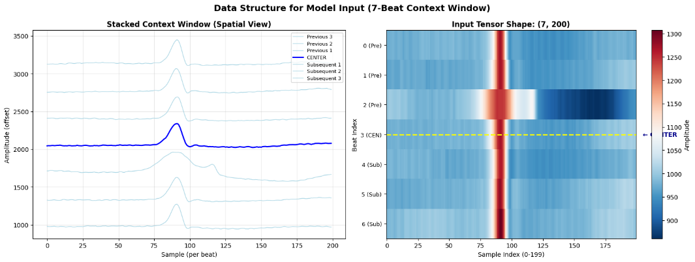

Fig. 3 Final input tensor construction showing spatial and temporal stacked and heatmap view

Patient-Independent Partitioning and Normalization

To address the pervasive issue of data leakage found in prior studies [12], we enforced a strict record-wise splitting strategy. Instead of randomizing individual beats, the dataset (47 records) was partitioned based on unique patient IDs. This resulted in a Training set (70.3%), Validation set (13.4%), and Testing set (16.4%). Crucially, this protocol guarantees that the test set consists exclusively of patients entirely unseen during the training phase, providing an unbiased assessment of generalization capability [22].

Following the split, a Z-score normalization (Standard Scaler) was applied to standardize signal amplitudes. To strictly adhere to the "no-peeking" principle, the statistics (mean and standard deviation) were computed solely on the training set and subsequently applied to the validation and test sets.

1D-CNN Architecture

Instead of utilizing computationally expensive pre-trained models, we engineered a bespoke 1D-CNN architecture tailored specifically for the 7-beat context window. As detailed in Table 2, the network features a hierarchical design. Stages 1 and 2 function as primary feature extractors, utilizing broad kernels (k=5) and Max-Pooling to capture fundamental morphological waveforms (P-QRS-T) while down-sampling dimensionality.

In Stage 3, the network deepens to 128 filters with a tighter kernel (k=3) to resolve high-frequency rhythmic patterns. Crucially, this stage employs Global Average Pooling (GAP) instead of traditional flattening. GAP summarizes temporal feature maps into a concise vector, significantly minimizing parameter count and mitigating overfitting risks. The classification head (Stages 4-5) comprises a dense layer followed by a Sigmoid activation to output a normalized probability score. All stages figured in Table 2.

Table 2. Summary of the proposed 1D-CNN architecture parameters
Stage | Layer Configuration | Filters / Units | Kernel Size | Output Shape | Activation
1 | 1D-Conv + MaxPool | 32 | 5 | (700,32) | ReLU
2 | 1D-Conv + MaxPool | 64 | 5 | (350,64) | ReLU
3 | 1D-Conv + GAP | 128 | 3 | (128) | ReLu
4 | Full Connected (Dense) | 64 | - | (64) | ReLU
5 | Output Layer | 1 | - | 1 | Sigmoid

The model was trained using the PyTorch framework. To address the dataset's class imbalance, we implemented a Weighted Cross-Entropy Loss function. Penalties for misclassifying the minority (Abnormal) class were weighted higher ($≈$ 1.56), compelling the gradient descent to prioritize sensitivity towards pathological signals. Optimization employed AdamW with a ReduceLROnPlateau scheduler and an Early Stopping mechanism (patience=15 epochs) to ensure convergence to a generalizable solution.

Real-Time Deployment and Rolling Buffer Mechanism

To bridge the gap between offline modeling and clinical utility, the trained 1D-CNN was integrated into a real-time monitoring architecture. As outlined in the functional design, the system streamlines the workflow from patient data streaming to automated decision support.

A critical engineering challenge in this workflow is the dimensional mismatch between continuous patient streams and the model's structured input requirement. To resolve this, we developed a backend Rolling Buffer Mechanism. Functioning as a First-In-First-Out (FIFO) queue, this mechanism dynamically accumulates incoming signals. Once the buffer is filled, it automatically constructs the required tensor (3 previous + 1 center + 3 subsequent beats) and triggers the inference engine.

For operational efficiency, the model is exported to the ONNX (Open Neural Network Exchange) format. This optimization minimizes inference latency, enabling the system to render classification results—distinguishing Normal from Abnormal beats with probability scores—instantaneously on the user dashboard.

Results and Discussion

Classification Performance Analysis
To evaluate the model's diagnostic capability, we analyzed the confusion matrix (Fig. 4) and comprehensive performance metrics on the unseen test set. The proposed 1D-CNN achieved an overall Accuracy of 98.03%.

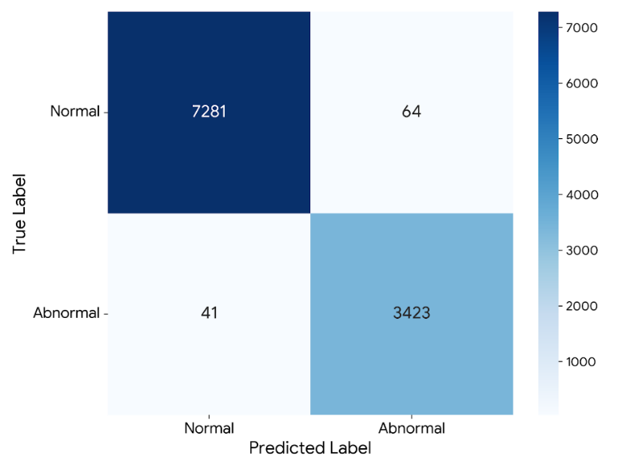

Fig 4. Confusion Matrix on the test set. The distribution reveals a high True Positive count with minimal False Negatives.

A critical requirement for biomedical screening is high sensitivity. The confusion matrix reveals that out of 3,464 abnormal beats, the model yielded only 41 False Negatives, corresponding to a Recall of 98.82%. This confirms that the Weighted Cross-Entropy Loss strategy successfully compelled the model to prioritize the detection of minority class arrhythmias. The high AUC-ROC (99.93%) further attests to the model's excellent class separability.

Real-Time Zero-Shot Validation
The system's operational robustness was validated through a "zero-shot" deployment simulation on an unmodified patient record (Fig. 5), which was explicitly excluded from training.

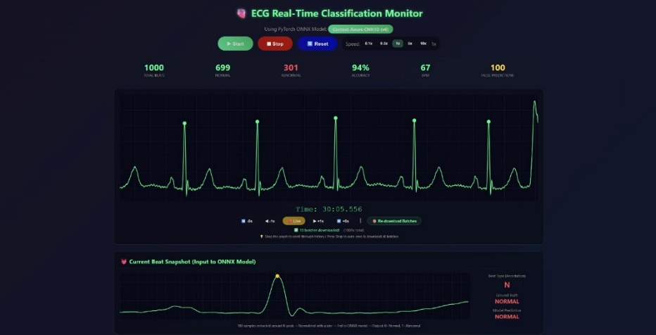

Fig. 5 Real-time classification interface showing successful detection of normal and abnormal.

In this strict simulation, the system maintained a real-time accuracy of 94%. While this represents a slight decrement from the 98.03% offline benchmark, it highlights the Generalization Gap attributed to physiological distribution shifts in new subjects. Nevertheless, maintaining accuracy above 90% without re-calibration confirms that the model has successfully learned robust, invariant morphological features.

Conclusion and Future Works

This study has demonstrated the successful development of a real-time ECG monitoring application that integrates a validated context-aware 1D-CNN model into a functional clinical decision support system. Rather than focusing solely on model performance, the proposed work emphasizes the practical realization of deep learning within an application-level architecture capable of processing continuous ECG streams in real time. The integrated system incorporates a rolling buffer mechanism to dynamically construct seven-beat context windows, enabling reliable arrhythmia detection while preserving temporal rhythm information essential for clinical interpretation. Through this design, the application effectively bridges the mismatch between offline deep learning models and real-time physiological data streams. Experimental evaluation confirms that the deployed application maintains high diagnostic reliability, achieving 98.03% accuracy on unseen test data and 94% accuracy in a zero-shot real-time simulation using a previously unseen patient record. These results demonstrate that the proposed application is robust against physiological variability and generalization challenges commonly encountered in real-world deployments. By combining a rigorously evaluated deep learning model with a user-centric application interface and real-time processing pipeline, this work provides a practical foundation for next-generation ECG monitoring systems. Future work will focus on extending the application to multi-class arrhythmia classification, multi-lead ECG integration, and deployment on resource-constrained wearable or edge devices for continuous cardiac health monitoring.

Data Availability

The dataset supporting the conclusions of this article is available in the MIT-BIH arrhythmia database repository, accessible at https://www.kaggle.com/datasets/taejoongyoon/mitbit-arrhythmia-database . The preprocessing code used to generate the 7-beat context window and the 1D-CNN model implementation are openly available in the GitHub repository at: https://github.com/abdielrivandi/context-windows.

Authorship Statement

Abdiel Ivan Rivandi: Resources, Methodology, Validation, Formal Analysis, Investigation, Data Curation, Writing – Original Draft, Visualization. Petra Michael: Methodology, Validation, Formal Analysis, Software, Investigation, Data Curation, Writing – Original Draft, Visualization. Dani Suandi: Conceptualization, Writing – Review & Editing, Supervision, Project administration, Methodology. Abba Suganda Girsang: Writing – Review & Editing, Supervision.

Declaration of Generative AI Usage

During the preparation of this work, the authors utilized Generative AI technologies to improve the readability and language quality of the manuscript. Additionally, AI tools were employed to assist in debugging and generating Python code for data visualization (figures). The authors reviewed and edited the output as needed and took full responsibility for the final content of the publication.

References
- Ashley, E.A., Niebauer, J.: Cardiology Explained. Remedica, London (2004).
- Hannun, A.Y., Rajpurkar, P., Haghpanahi, M., et al.: Cardiologist-level arrhythmia detection and classification in ambulatory electrocardiograms using a deep neural network. Nature Medicine 25, 65–69 (2019).
- Clifford, G.D., Azuaje, F., McSharry, P.: Advanced methods and tools for ECG data analysis. Artech House (2006).
- Sannino, G., De Pietro, G.: Deep learning for ECG signal classification: A review. Artificial Intelligence in Medicine 118, 102142 (2021).
- Ahmed, M.S., Khan, A.S., Ali, N.: ECG signal classification using deep learning techniques: A systematic review. Computers in Biology and Medicine 161, 107380 (2023).
- Faust, O., Hagiwara, Y., Hong, T.J., Lih, O.S., Acharya, U.R.: Deep learning for healthcare applications based on physiological signals: A review. Computer Methods and Programs in Biomedicine 161, 1–13 (2018).
- Panwar, M., Singh, S., Singh, R.: Real-time ECG Arrhythmia detection using deep learning. Biomedical Signal Processing and Control 95, 106300 (2025).
- LeCun, Y., Bengio, Y., Hinton, G.: Deep learning. Nature 521, 436–444 (2015).
- Acharya, U.R., Joseph, K.P., Kannathal, N., Lim, C.M., Suri, J.S.: Heart rate variability: a review. Medical and Biological Engineering and Computing 44(12), 1031-1051 (2006).
- Ebrahimzadeh, E., Pooyan, M., Bijar, A.: Prediction of sudden cardiac death using nonlinear analysis of HRV. (2014).
- Kiranyaz, S., Avci, O., Abdeljaber, O., et al.: 1D convolutional neural networks and applications: A survey. Mechanical Systems and Signal Processing 151, 107398 (2021).
- Kiranyaz, S., Ince, T., Gabbouj, M.: Real-time patient-specific ECG classification by 1-D convolutional neural networks. IEEE Transactions on Biomedical Engineering 63(3), 664–675 (2016).
- Acharya, U.R., Fujita, H., Lih, O.H., et al.: Automated Arrhythmia detection using spectrogram and deep convolutional neural network with long duration ECG signals. Information Sciences 405, 112–127 (2017).
- Eleyan, A., Alboghbaish, E.: Electrocardiogram signals classification using deep-learning-based incorporated convolutional neural network and long short-term memory framework. IEEE Access 12, 14223–14232 (2024).
- Warrick, P.A., Homsi, M.N.: Ensembling convolutional and long short-term memory networks for electrocardiogram arrhythmia detection. Physiological Measurement 38(8), 1545 (2017).
- Polat, K., Gunes, S.: Principles of dataset splitting in validation of biomedical models. Journal of Medical Systems 43(1), 1–10 (2019).
- Luz, E.J.S., Schwartz, W.R., Cámara-Chávez, G., Menotti, D.: ECG-based heartbeat classification for arrhythmia detection: A survey. Computer Methods and Programs in Biomedicine 127, 144–164 (2016).
- Yildirim, O., Baloglu, U.B., Tan, R.S., Acharya, U.R.: Arrhythmia detection using deep convolutional neural network with long duration ECG signals. Computers in Biology and Medicine 102, 411–420 (2018).
- Baloglu, U.B., Talo, M., Yildirim, O., Tan, R.S., Acharya, U.R.: Classification of myocardial infarction with multi-lead ECG signals and deep CNN. Pattern Recognition Letters 122, 23–30 (2019).
- Zheng, J., Zhang, Y., Wang, L., Chen, H., Wu, X.: A deep learning framework for ECG-based heartbeat classification using spatial pyramid pooling. Neural Networks 122, 160–169 (2020).
- Alinsaif, S.: Unraveling arrhythmias with graph-based analysis: A survey of the MIT-BIH database. Computation 12(2), 21 (2024).
- Moody, G.B., Mark, R.G.: The impact of the MIT-BIH Arrhythmia Database. IEEE Engineering in Medicine and Biology Magazine 20(3), 45–50 (2001).
- Ribeiro, A.H., Ribeiro, M.H., Paixão, G.M., et al.: Automatic diagnosis of the 12-lead ECG using a deep neural network. Nature Communications 11, 1760 (2020).
- Pan, J., Tompkins, W.J.: A real-time QRS detection algorithm. IEEE Transactions on Biomedical Engineering 32(3), 230–236 (1985).
- Chicco, D., Jurman, G.: The advantages of the Matthews correlation coefficient over F1 score and accuracy in binary classification evaluation. BMC Genomics 21(1), 6 (2020).

